Title of Abstract in Size 18 font
Forename1 SURNAME2, Forename2 SURNAME2, Organisation1
Forename3 SURNAME3, Organisation2
corresponding.author@anyone.com

Authors who wish to present their work at the DualSPHysics Users Workshop are requested to submit a 1-page abstract. This page should include only including text, Figures and References like this example. Authors are requested to use Size 11 or 12 font using Times New Roman or Arial styles. Figures should have a Figure number and caption and be referred to in the text such as shown in Figure 1.
The quality of the abstracts will be assessed using averaged ratings for 4 equally important categories: i.e. (1) Novelty, (2) Code Improvements, (3) Current Limitations, and (4) Validations & predictive improvements over the state-of-the-art.
We thoroughly encourage abstracts to identify new applications of DualSPHysics highlighting where DualSPHysics does well and where it performs poorly. Comparisons are recommended with high-quality validation cases and with data sets from experiments, field investigations or real applications.
A pdf-version of the abstract should be submitted by the 22nd of December 2014 via email to dualsphysics@gmail.com.
The abstract will be reviewed by the Workshop Committee. Notification of acceptance for publication will be given by 31st December 2014 via email.
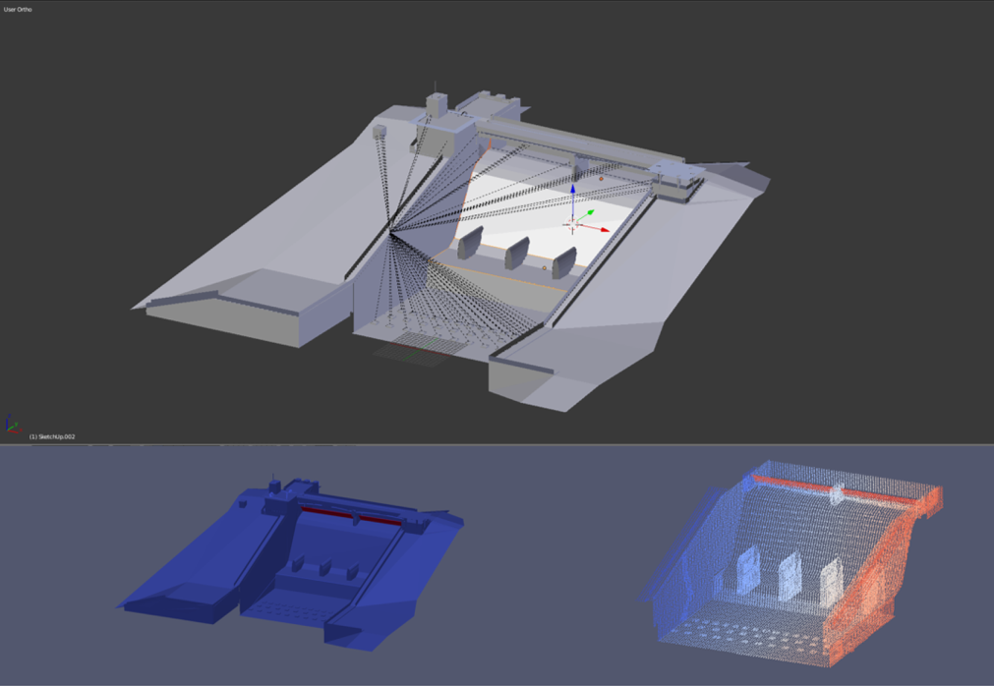
Figure 1 - Example figure and caption of DualSPHysics simulation

References:
Crespo AJC, Domínguez JM, Rogers BD, Gómez-Gesteira M, Longshaw S, Canelas R, Vacondio R, Barreiro A, García-Feal O. 2015. “DualSPHysics: open-source parallel CFD solver on Smoothed Particle Hydrodynamics (SPH)”, Computer Physics Communications, 187: 204-216, doi: 10.1016/j.cpc.2014.10.004.

